LONDON ROAD WEST NEWS
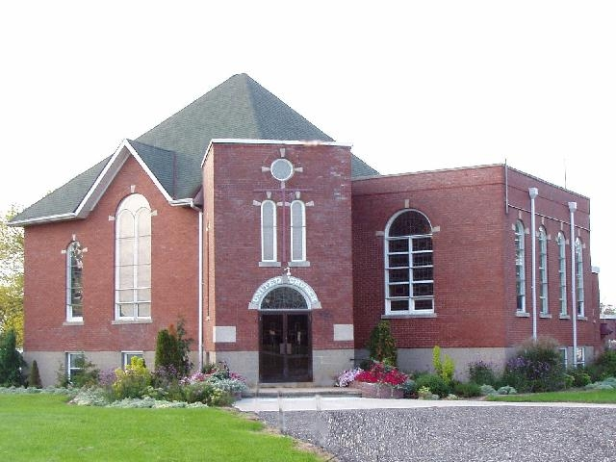
Let us all bask in this beautiful weather and be Thankful.
Our fall colours are starting to show and although we are still unable to open as a church, we hope you know that we keep you in our thoughts and prayers always. The numbers of COVID cases are growing again, we are unsure of what lies ahead, but we know God is with us always.
Remember to not become complacent in the care you have taken to keep yourself safe, but to continue to isolate when needed, wash your hands frequently, distance always, wear a mask and be kind.
Our virtual services have been running for a few weeks – this is new to us, so please bare with us as we refine and hone our skills on providing these services. We hope you find spiritual refreshment from them.
The services may be reached through our website – www.londonroadwestunitedchurch.com under “Virtual Services”. You should see the date, simply click and you will be able to watch from that page.
The link below will take you directly to the “You Tube” view of all services, again listed by date.
https://www.youtube.com/channel/UCvEzH6Emb6Asp-n4HxbyQEg
Simply click on the date you wish to see and Watch/Listen in the comfort of your own home.
If you have a friend or family member who does not have access to the virtual world, please take some time to share the service from your own device, be it a cell phone or an Ipad. Or ask a family member if they could look this up and share it with you. We hope to reach all of our congregation in some manner with a “Sunday Morning” service at any time.
October has always been a busy month here at London Road West and we have three very special services coming up to share with you.
First, this Sunday, October 4th is World Wide Communion, and we hope you will take the opportunity to share in the bread and wine through the virtual service or through the written service provided to those who do not have computer access.
Our “Thanksgiving Service” will follow on Sunday, October 11th and again we hope you are able to share our many good blessings in our Thanksgiving service along with family or friends as is possible through the new rules set out for social gatherings.
And lastly, our “167th ANNIVERSARY” as a London Road West congregation. Many changes, many disasters, many heartbreaks and many celebrations, have taken place over those years, but one thing remains, we are here as a congregation, we are here for the long-run, we are here for you, and we are here to work together. Thanks be to God.
September was just as busy here this year. The Search Committee continue to search. We started up the virtual services, we built a Harvest Wagon, which has brought fruit and vegetables, and grocery items to our wagon, which we have passed on to those in more need. We hosted our Beef Dinner for the 39th year, and this year curbside which was very well received and very successful. Thanks to all those who worked so hard to make this happen.
Our women, under COVID rules, gathered and made 856 Beef Pies on Monday. There are still some available if you didn’t get any. $4 a pie – Just call the church 519-542-2084 and leave a message.
A huge “Thank You” to Linda Ross who keeps our gardens looking beautiful every season and Fall is no exception. As well a Thank You to our men who continue to be sure our building is safe, maintained and no issues while we can’t be in the building. We recently had a breaker failure, while preparing for our beef dinner and thanks to Kelly Nickles, our panel was back up and running in no time.
If you are aware of someone who is ill, in need of a prayer, or a friendly call, let us know. You can always call the church at 519-542-2084 and leave a message – we will make sure it gets to the right person. If we all work together, no one will be left behind.
As always, we thank you for your continued support.
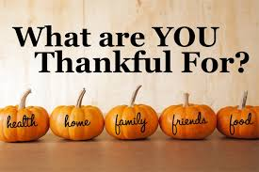

Be Safe and Stay Healthy
Betty
“London Road West United Church is a welcoming congregation celebrating God’s presence through worship, music, spiritual enrichment and outreach.”
“Be with us: Celebrate GOD!”

“London Road West United Church is a welcoming congregation celebrating God’s presence through worship, music, spiritual enrichment and outreach.”
“Be with us: Celebrate GOD!”

