LONDON ROAD WEST NEWS
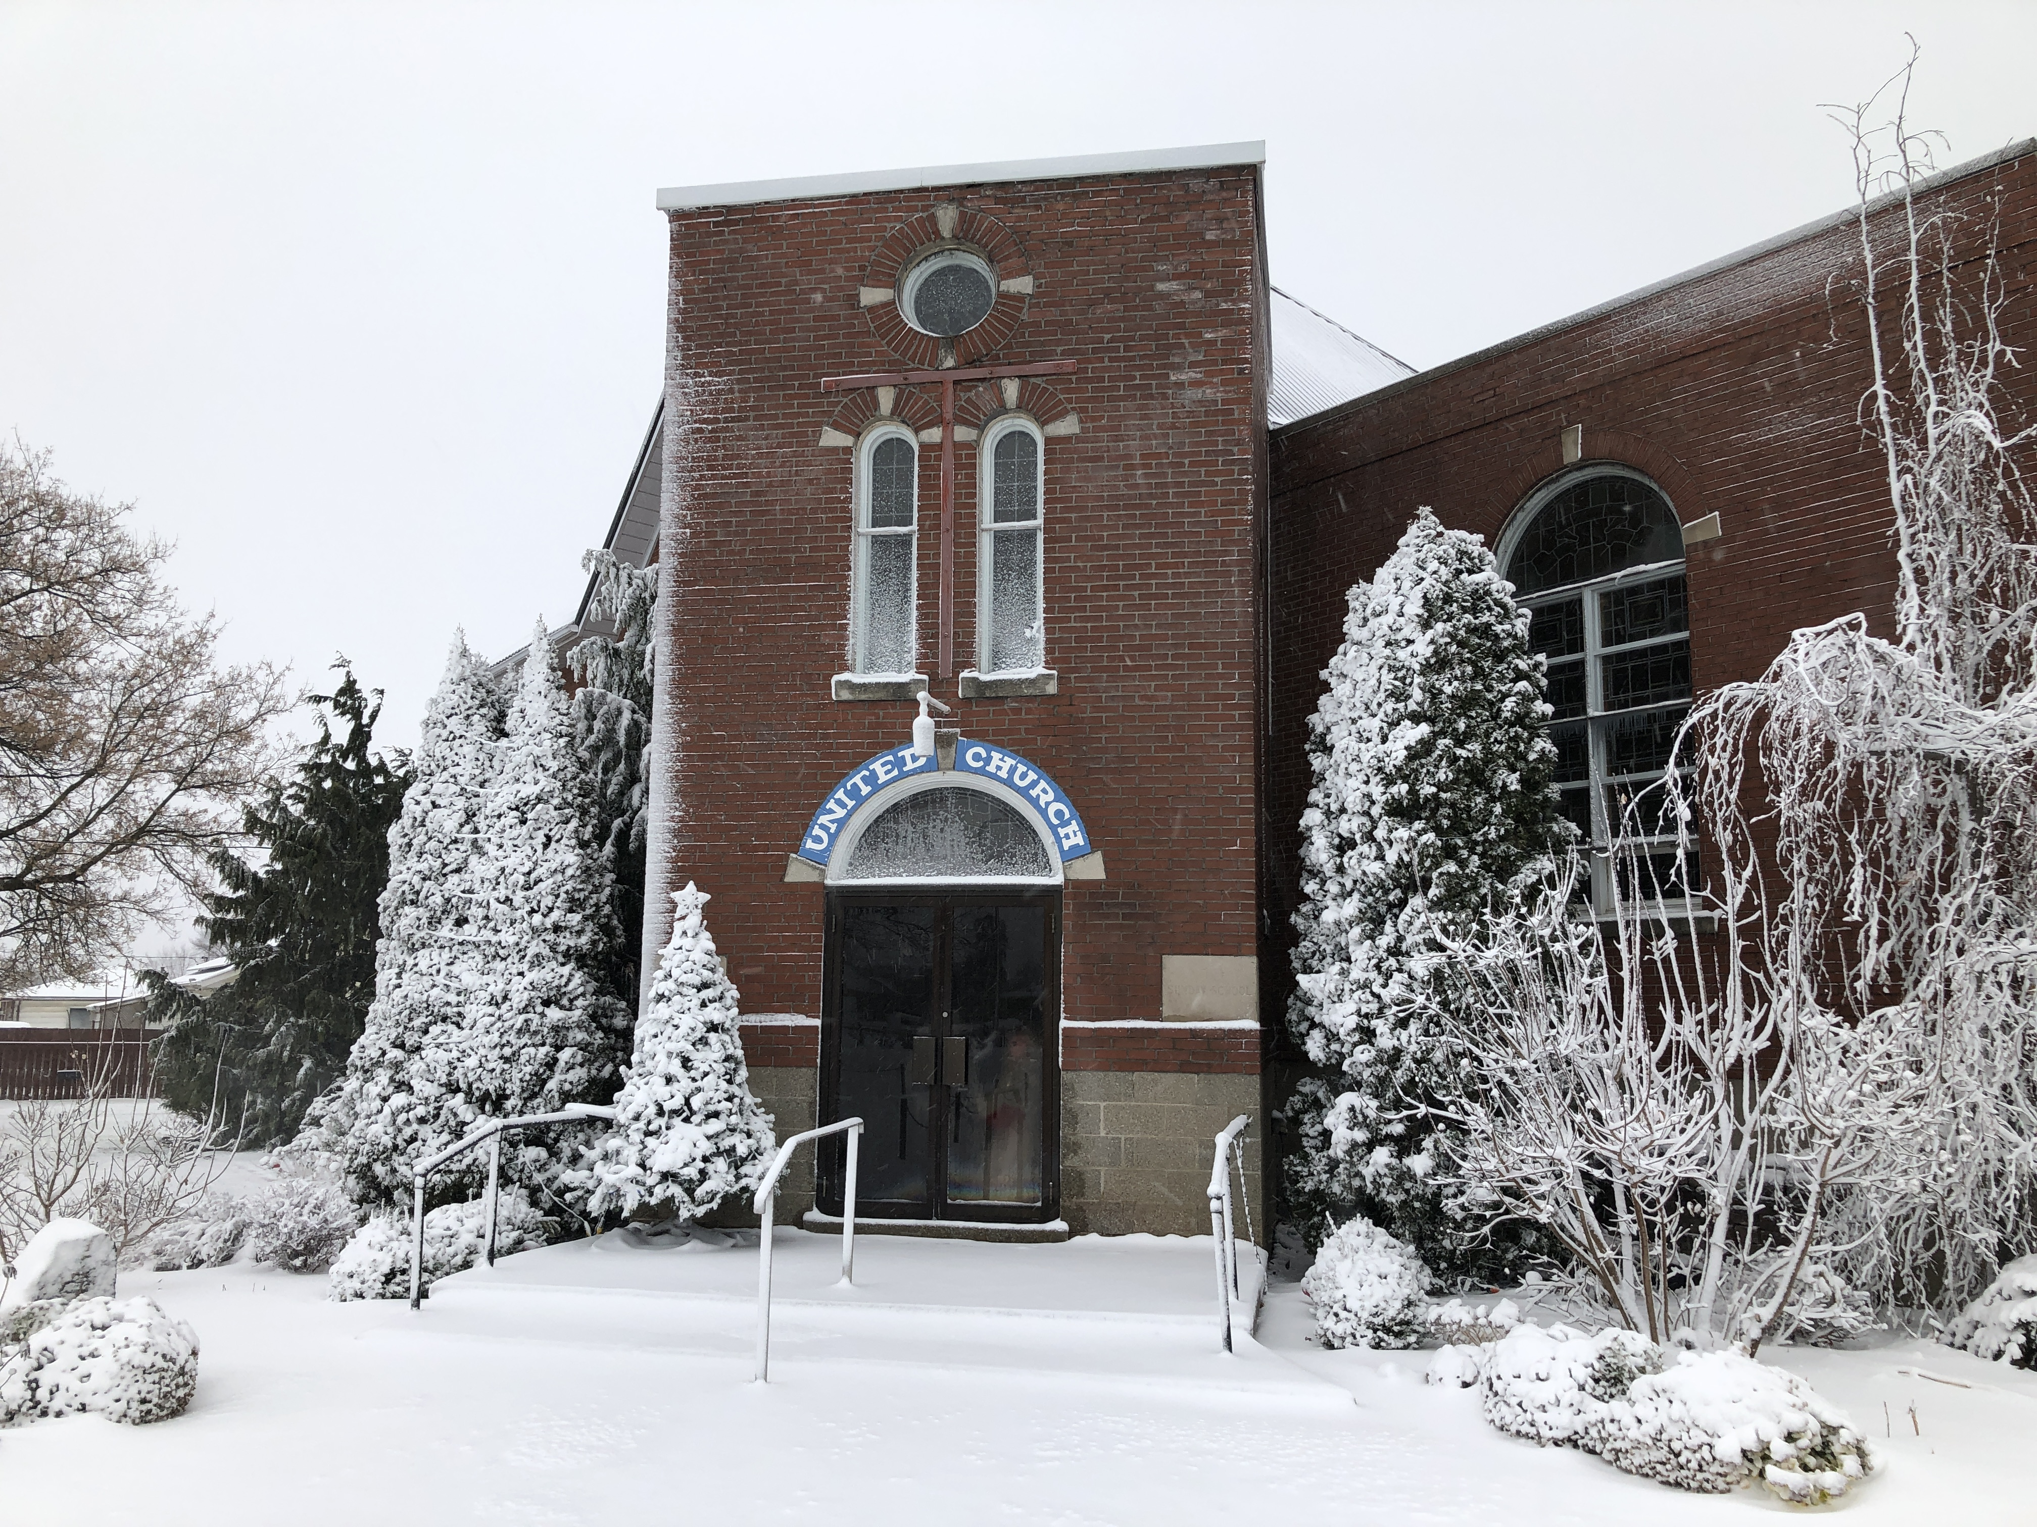
December 2020
Winter is upon us and we hope that you continue to be well and safe.
REMINDER:
If you ordered Specialty Butter Tarts and/or Poinsettias, please pick up
SATURDAY, DECEMBER 5th BETWEEN 11:00 AM and 12:00 NOON
Please have correct payment - Tarts $10 a Dozen or $6 a Half-Dozen
Poinsettias $12
There have been a number of activities happening virtually or within protocols and we just wanted to keep you updated as to what has been happening and what is planned.
Below you will see the Highlights of our recent Parks Family Bequest Committee meeting and the Regular Official Board Meeting. Should you have any comments or questions, please give the Church a call at 519-542-2084.
PARKS FAMILY BEQUEST & OFFICIAL BOARD HIGHLIGHTS
Tuesday, November 24th , 2020 6:30 PM
- Teleconference meeting for the Parks Family Bequest Committee and the regular Official Board Meeting
- Anticipated interest from the Parks Family principle amount for use in 2021 is approximately $6200
- Motion was accepted to transfer the interest funds to the General Funds for use during 2021
- Principle Amount invested from the Parks Family funds is approximately $338,000
- Our Treasurer reports that we are in a healthy situation going into 2021 under the current circumstances
- It was the general consensus that the Virtual services are beneficial and people are viewing them
- We will continue with these services until a decision is made to re-open which will be further discussed in the new year and based on what continues to happen in this area
- There are a number of up-coming events where we will use our transmitter which is an enhancement to our sound system – Please watch for communications on the up-coming Christmas celebrations
- Dick Chowen has been appointed our Regional Representative
- We encourage everyone to access our virtual services and our website information
- A decision was made to offer an Drive In Christmas Eve service, weather permitting
- Please continue to be aware of others in our congregation and let Session members know if you are aware of any special needs
- Please continue to be well
* * * * *
On behalf of London Road West Sunday School, we would like to thank everyone for their generous support of our Drive Thru Toy Drive. Your support was overwhelming. So many toys were collected !
The toys will all be donated to The House By the Side of The Road. This year has been a very difficult for many families, your gifts will bring Christmas joy to many, many children.
Again thank you for you support!
LRW Sunday School and CE committee.

* * * * *
Saturday, December 12th – could be anytime – Special Delivery to You
“MERRY CHRISTMAS”
* * * * *
SUNDAY, DECEMBER 20TH 6:30 PM
“CHRISTMAS IN THE LOT”
Come to our Parking Lot, Tune your Car Radio to FM 98.5
Hear our Christmas Music
Watch for more details
* * * * *
We “Thank” you for supporting these activities and we hope that we can help make Christmas will participate in all these events in the best way that fits for you.
We encourage you to continue watching our Virtual Services weekly and if you haven’t already, check out our website
Our services may be reached through our website – www.londonroadwestunitedchurch.com under “Virtual Services”. You should see the date, simply click and you will be able to watch from that page.
The link below will take you directly to the “You Tube” view of all services, again listed by date.
https://www.youtube.com/channel/UCvEzH6Emb6Asp-n4HxbyQEg
Simply click on the date you wish to see and Watch/Listen in the comfort of your own home.
If you are aware of someone who is ill, in need of a prayer, or a friendly chat, let us know. You can always call the church at 519-542-2084 and leave a message – we will make sure it gets to the right person. If we all work together, no one will be left behind.
As always, we thank you for your continued support.

Be Safe and Stay Healthy
Betty

“London Road West United Church is a welcoming congregation celebrating God’s presence through worship, music, spiritual enrichment and outreach.”
“Be with us: Celebrate GOD!”

